Name : Prajakta Keer
Class : TE 10
Roll No : 33231

Problem Statement:- Understand servlet life cycle, create login page and apply proper
validations with appropriate messages using doGet()/ doPost()
methods.
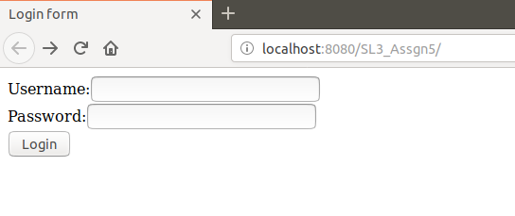
Design of login page :

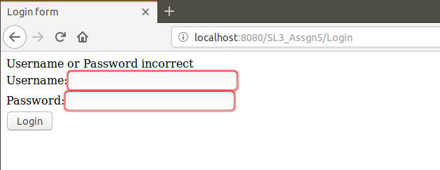

Validation for null input :

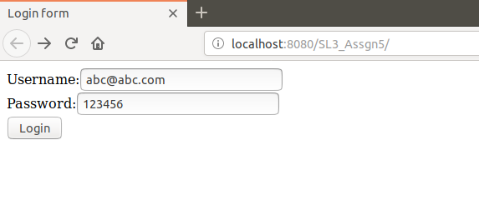
After inserting correct login credentials welcome message is displayed:

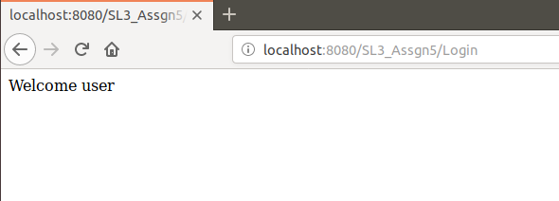

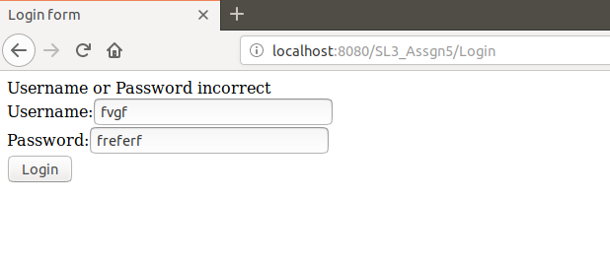
After inserting invalid credentials :

List of files :
- index.html
- web.xml
- Login.java
- validate.java
- Welcome.java

Code for index.html :
<html>
<head>
<title>Login form</title>
</head>
<body>
<form method="post" action="Login">
Username:<input type="text" name="uname" required/><br/>
Password:<input type="text" name="pass" required/><br/>
<input type="submit" value="Login" />
</form>
</body>
</html>

Code for web.xml :
<?xml version="1.0" encoding="UTF-8"?>
<web-app version="4.0" xmlns="http://xmlns.jcp.org/xml/ns/javaee" xmlns:xsi="http://www.w3.org/2001/XMLSchema-instance" xsi:schemaLocation="http://xmlns.jcp.org/xml/ns/javaee http://xmlns.jcp.org/xml/ns/javaee/web-app_4_0.xsd">
<servlet>
<servlet-name>Login</servlet-name>
<servlet-class>Login</servlet-class>
</servlet>
<servlet>
<servlet-name>Welcome</servlet-name>
<servlet-class>Welcome</servlet-class>
</servlet>
<servlet-mapping>
<servlet-name>Login</servlet-name>
<url-pattern>/Login</url-pattern>
</servlet-mapping>
<servlet-mapping>
<servlet-name>Welcome</servlet-name>
<url-pattern>/Welcome</url-pattern>
</servlet-mapping>
</web-app>

Code for Login.java :
import java.io.*;
import javax.servlet.*;
import javax.servlet.http.*;
import java.sql.*;

public class Login extends HttpServlet {

protected void doPost(HttpServletRequest request, HttpServletResponse response)
throws ServletException, IOException {
response.setContentType("text/html;charset=UTF-8");

String uname = request.getParameter("uname");
String pass = request.getParameter("pass");
PrintWriter out = response.getWriter();

if(validate.checkUser(uname, pass)) {
RequestDispatcher r = request.getRequestDispatcher("Welcome");
r.forward(request, response);
}
else
{
out.println("Username or Password incorrect");
RequestDispatcher r = request.getRequestDispatcher("index.html");
r.include(request, response);
}
out.close();
}
}

Code for validate.java:
//import java.io.PrintWriter;
import java.sql.*;

public class validate {
public static boolean checkUser(String uname,String pass)
{
boolean st =false;
try {

//loading drivers for mysql
Class.forName("com.mysql.jdbc.Driver");

//creating connection with the database
Connection con = DriverManager.getConnection("jdbc:mysql://localhost:3306/sl3_a5?useSSL=false","root","password");
PreparedStatement ps = con.prepareStatement("select * from register where email=? and pass=?");
ps.setString(1, uname);
ps.setString(2, pass);
ResultSet rs =ps.executeQuery();
st = rs.next();
}
catch(Exception e) {
e.printStackTrace();
}
return st;
}
}

Code for Welcome.java :
import java.io.*;
import javax.servlet.*;
import javax.servlet.http.*;
import java.sql.*;

public class Welcome extends HttpServlet {

protected void doPost(HttpServletRequest request, HttpServletResponse response)
throws ServletException, IOException {
response.setContentType("text/html;charset=UTF-8");
PrintWriter out = response.getWriter();
out.println("Welcome user");
}
}

References :
- https://www.studytonight.com/servlet/login-system-example-in-servlet.php#
- SL3 Lab Manual
- Video Recording uploaded in MS Teams

